**SET CONCEPTS**

**A SET: -**

Is a collection of well-defined elements.

An element is an object or a thing that belongs in a set.

**Facts about sets**

The elements of a set must be enclosed in a curly bracket

The elements must be separated using commas e.g., set K = a, b, c

The name of a set must be written in capital letters.

**Example 1**

Given that set A = a, b, c, d

Set B = 1, 2, 3, 4

**Equivalent sets**

These are sets with the same number of elements but of different types.

Set symbols ( )

**Example**

Given that set A = a, b, c, d

B = 1, 2, 3, 4

Since set A and set B have the same number of elements.

 Set A and set B are equivalent sets

Set A Set B

**Equal sets**

These are sets with the same number of elements that are exactly the same.

Set symbol

**Example 1**

Set K = Hen, cow, dog

M = dog, Hen, Cow

Since set K and Set M have the same number and same elements,

Set K is equal to set M.

Set K = Set M

**Activity.**

Use equal or equivalent to describe the following sets.

(a) M = C, O, W and H = W, O, C

Set M __________ Set H

(b) R = a, b, c, d and H = 4, 6, 8, 9

Set R __________ Set H

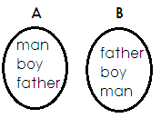(c)

Sets A ___________ Set B

(d) H = P, O, T and N = m, a, n

Set H __________ Set N

(e) R = D, R, U, M and K = M, U, R, D

Set R _________ Set K.

**Empty set / Null / void set**.

An Empty set (O) or

**Example**

Set T = whole numbers between 9 and 10

Set T is an empty set.

Set M = A pregnant father

Set M is an empty Set

**Activity**

Use empty or not empty

1. B = fish that can live on land

2. K = bulls which produce milk

3. M = Birds without wings

4. R = A class with 10 pupils

5. H = Birds which produce babies

**Intersection Sets**

Is a set of common elements in two or more sets.

Set symbol **∩**

**Examples**

1. Given that set K = Kampala, Mukono, Wakiso

M = Entebbe, Kampala, Wakiso

K ∩ M = Kampala, Wakiso

Find R n M of the sets below.

R = cow, goat, rabbits, rat

M = Hen, cow, rabbit, sheep

R ∩ M = cow, rabbit

**Activity**

1. K = Even numbers less than 10

R = Prime numbers less than 10

List members of Set

(i) K (ii) R (iii) Find K ∩ R

4. Given set H = 1, 3, 5, 7, 9

R = 0, 2, 4, 7, 5

List the common members.

5. K = , , and M = , ,

Find K ∩ M

6. Given that V = a, e, i, o, u

Z = a, b, c, d, i

Find V ∩ Z

7. Set K = 2, 3, 4, 5

Set M = 5, 6, 4, 8

Find K ∩ M

**UNION SETS**

Is a set containing all members of two or more sets.

Set symbol for union set is **U**

**Examples**

Set A = 2, 3, 4, 5

Set B = 4, 3, 6, 7

Set A U B = 2, 3, 4, 5, 6, 7

**Example: II**

Set N = , ,



Set T = , , ,



Set NUT =

**ACTIVITY:**

1. T = 2, 3, 4 K = 5, 6, 7

Find TUK.

2. M = boy, girl, man T = man, boy, teacher

Find M U T

3. A = 4, 5, 6, 7 B = 5, 8, 9, 6

Find A U B

4. Find D U E if D = a, e, i, o E = d, e, g, h

5. P = 6, 7, 8 Q = 9, 4, 5, 8

Find PUQ

6. A = y, m, n, k B = r, s, t, m

Find AUB

7. P = even numbers less than 10

K = natural numbers less than 10

Find PUK

**JOINT AND DISJOINT SETS**

Disjoint Sets are sets without common members.

**Examples of disjoint sets.**

1. Given that;

Set A = {1, 2, 3, 4, 5}

Set B = {a, b, c, d}

A∩B = { }

Therefore,

Set A and B are disjoint Sets.

**JOINT SETS / INTERSECTING SETS**

These are sets with common elements

**Examples of joint sets**

Set P = {m, e, a, t}

Set Q = {b, e, a, d}

P∩Q = {a, e}

Therefore:

Set P and Set Q are joint sets

**DIFFERENCE OF TWO SETS**

Is a set of elements that belong to only one set.

**Example**

Given set A = {2, 3, 4} and Set B = 5, 3, 4}. Find;

(ii) A-B

Set A – B = {2}

(ii) B-A

Set B – A = {5}

**ACTIVITY**

1. Set T = {odd numbers up to 7}

Set N = {even numbers up to 7}

Find T – N

Find N - T

2. T = {a, b, c, d, e}

S = {a, e, i, o, u}

Find:

1. T - s (b) S – T

2. Given that: X =



W =

Find: (a) W - X (b) X - W

3. Set R = {1, 2, 3,4, 5, 6}

Set V = {1, 3, 5, 7, 9}

Find: (a) R - V (b) V - R

4. Set K = {all even numbers less than 10}

Set L = {all odd numbers less than 10}

1. How many elements are in K – L?
2. List down all members of L – K.

5. Set M = {the first 4 multiples of 3}

Set N = {2, 3, 4, 5, 7}

Find: (a) N – M (b) M – N

**PARTS OF A VENN DIAGRAM**

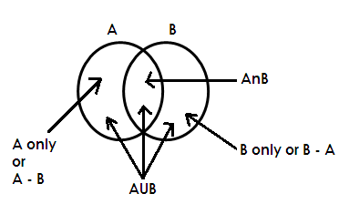Given Set A and Set B

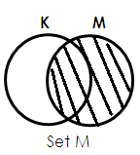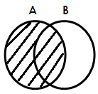**DESCRIBING SHADED PARTS OF A VENN DIAGRAM**

1. 2.

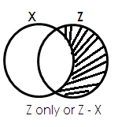 Set A

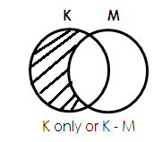

3. 4.

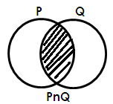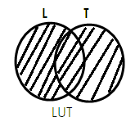

5. 6.

**ACTIVITY**

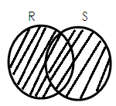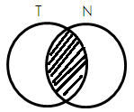1. Describe each of the shaded region in the Venn diagrams below.

(a) (b)

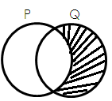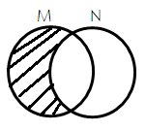

1. (d)

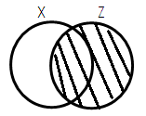 (e) (f)

2. Study and shade the Venn diagram as instructed below.

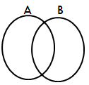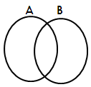 (a) Shade A∩B (b) Shade AUB

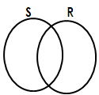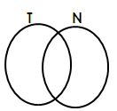 (c) Shade T – N (d) Shade R - s

1. 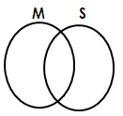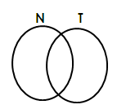Shade N U T (f)Shade M - S

**LISTING ELEMENTS IN A SET FROM VENN DIAGRAM**

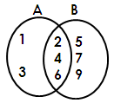Use the Venn diagram below to answer questions that follow.

Find;

(a) A∩B (b) A only (c) Set B

**Soln. Soln. Soln.**

A∩B = {2, 4, 6} A only = {1,3} Set B = {2, 4, 6, 5, 7, 9}

(d) B - A (e) AUB

**Soln. Soln.**

B – A = {5, 7, 9} AUB = {1, 2, 3, 4, 5, 6, 7, 9}

**ACTIVITY**

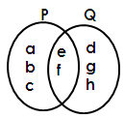1. Below is a Venn diagram, use it to answer questions that follow.

Find; (a) Set P (b) Set Q (c) P∩Q

(d) PUQ (e) P – Q (f) Q - P

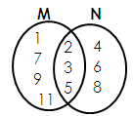2. Use the Venn diagram below to answer questions that follow.

Find; (a) Set M (b) Set N (c) M∩N

(d) MUN (e) M – N (f) N – M

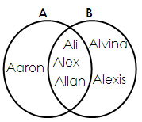3. Use the Venn diagram below to answer questions that follow.

Find; (a) Set B (b) Set A (c) A∩B

(d) AUB (e) B – A (f) A – B

**FINDING NUMBER OF ELEMNETS FROM A VENN DIAGRAM**

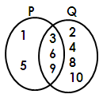Note: To find the number of elements in a Venn diagram, first list down the elements, then count to get the number.

Find; (a) n(P) (b) n(Q)

**Soln.**   **Soln.**

P = {1, 5, 3, 6, 9} Q = {2, 4, 8, 10, 3, 6, 9}

n(p) = 5 n(Q) = 7

(c) n(P∩Q) (d) n(PUQ)

**Soln. Soln.**

P n Q = {3, 6, 9} PUQ = {1, 5, 3, 6, 9, 2, 4, 8, 10}

n(P∩Q) = 3 n(PUQ) = 9

(e) n (P- Q) (f) n (Q – P)

Soln. Soln.

P – Q = {1, 5} Q – P = {2, 4, 8, 10}

n(P-Q) = 2 Therefore n(Q-P) = 4

**ACTIVITY**

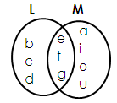1. Below is a Venn diagram. Use it to answer questions that follow.

Find; (a) n(L) (b) n(M) (c) n(L∩M) (d) n(LUM)

(e) n(L – M) (f) n(M – L)

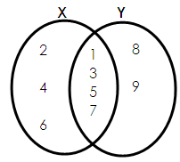2. Use the Venn diagram below to answer questions that follow.

Find; (i) n(x) (ii) n(Y) (iii) n(X∩Y)

(iv)n(XUY) (v) n(X – Y) (vi) n(Y – X)

**REPRESENTING ELEMENTS ON A VENN DIAGRAM**

**Examples:**

1. Given that; Set A = {1, 3, 5, 7, 9, 11}

Set B = {2, 3, 5, 7, 11}

Represent the above sets on the Venn diagram below;

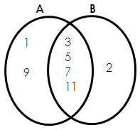

2. Is Set X = {all even numbers less than 10}

Set Y = {all counting numbers below 7}

Represent Set x and Set Y on the Venn diagram below;

**Soln.**

X = {0, 2, 4, 6, 8}

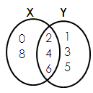 Y = {1, 2, 3, 4, 5, 6}

**ACTIVITY**

1. Given that;

Set K = {a, e, I, o, u} and Set L = {a, b, c, e, f, g, h, i}

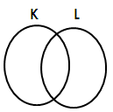 Represent the two sets on the Venn diagram below;

2. Given that;

Set P = {10, 11, 12, 13, 14, 15} Set R = {10, 12, 14, 16, 18, 20}

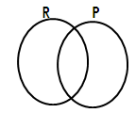 Represent set P and set R on the Venn diagram below.

3. If M = {all factors of 12} and N = {counting numbers less than 7}

Draw a Venn diagram and represent set A and set B if;

Set A = {first four prime numbers} and Set B = {1, 3, 5, 7, 9}

4. Draw a Venn diagram representing set G and set H given that;

Set G = {cow, pig, goat, cat} and Set H = {rat, lion, cat, zebra, cow}

**TOPIC 2:**

**WHOLE NUMBERS**

**PLACE VALUES OF WHOLE NUMBERS**

A place value is a position of a digit in given number.

**Finding place values of whole numbers.**

**Examples**

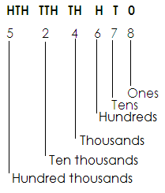Find the place value of each digit in the given number 524678.

Find the place value of the underlined digit.

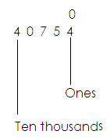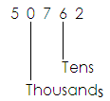(a) (b)

**Activity:**

1. Find the place value of each digit in the following.

(a) 3046 (b) 432467

2. Find the place value of 9 in the numeral 90676.

3. Find the place value of 6 in 75670.

4. Find the place value of the underlined digit in the following.

 (a) (b) 34067 (c) 70004 (d) 40346

**VALUES OF DIGITS**

A value is a product of a digit and its place value.

Value = Digit x place value

**Finding values**

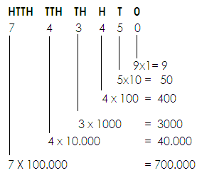1. Find the value of each digit in 743450.

2. Find the value of the underlined digit.

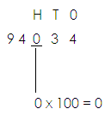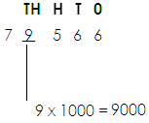 (a) (b) 7 9 5 6 6

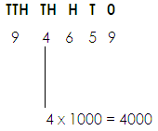3. Find the value of 4 in 94659.

**Activity:**

1. Find the value of each digit in these numbers.

(a) 403 (b) 94630 (c) 506078

2. Find the value of 0 in 50763.

3. Find the value of 5 in 65903.

4. Find the value of the underlined digit.

(a) 79034 (b) 906456

**FINDING SUM, DIFFERENCE AND PRODUCTS OF VALUES AND PLACE VALUES OF DIGITS IN A GIVEN NUMBER.**

**Examples.**

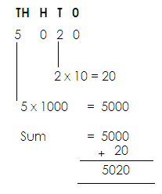Find the sum of value of 5 and value of 2 in 5020.

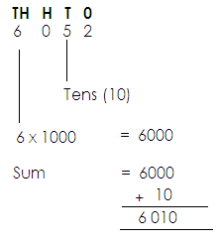Find the sum of value of 6 and place value of 5 in 6052.

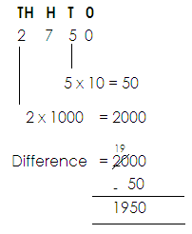2. Find the difference in the value of 2 and value of 5 in 2750.

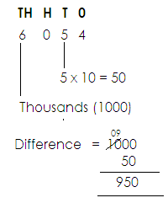3. Find the difference in the place value of 6 and value of 5 in

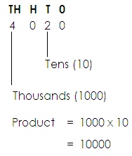4. Find the product of the place value of 4 and place value 2 in

**Activity:**

1. What is the sum of the value of 6 and 4 in the number 7641?

2. Find the sum of the value of 2 and the value of 9 in 2498.

3. What is the difference between the value of 9 and the value of 5 in the number 7905?

4. Which answer do you get when you multiply the value of 4 and the place value of 7 in 54073?

5. Work out the difference of the value of 3 and the value of 8 in the number 3841.

6. Find the product of the place value of 8 and the place value of 6 in 8697.

7. What is the difference between the place value of 4 and the place value of 3 in 547381?

**EXPANDING WHOLE NUMBERS**

**NOTE:**

Numbers are expanded in three ways;

1. Using place value

2. Values

3. Powers / exponents / indices

**USING PLACE VALUES**

**Examples**

1. Expand 394 using place values

Soln.

**H T 0**

3 9 4

(3 x 100) + (9 x 10) + (4 x 1)

2. Express 8742 in expanded form using place value

**Th H T 0**

8 7 4 2

8 thousand + 7 hundred + 4 tens + 2 ones.

**Activity:**

Express the following numbers in expanded form using place values.

1. 903 2. 7411

3. 80065 4. 87

5. 763294 6. 2635

7. 2579

**USING VALUES**

Examples:

1. Expand 3579 using values

**Soln.**

**Th H T 0**

3 5 7 9

= (3 x 1000) + (5 x 100) + (7 x 10) + (9 x 1)

= 3000 + 500 + 70 + 9

1. Express 60409 in expanded form using values.

**Tth Th H T 0**

6 0 4 0 9

= (6x 10.000) + (0 x 1000) + (4 x 100) + (0 x 10) + (9 x 1)

= 60000 + 0 + 400 + 0 + 9

**Activity**:

Expand the following using values.

1. 82 2. 709 3. 43759

4. 1094 5. 83271 6. 1991

**USING POWERS OR EXPONENTS**

A power is the number of times a quantity has to be multiplied by itself.

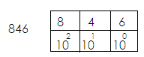**Examples**:

1.

(8x102) + (4x101) + (6x100)

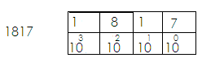2. Write 1817 in expanded form using exponents.

1817



**Activity.**

**Writing the following numbers in expanded form using indices or powers.**

1. 2772 2. 134 3. 4096 4. 94

5. 8751 6. 678 7. 70635

**WRITING EXPANDED NUMBERS AS SINGLE NUMERALS.**

**Examples:**

1. Which number has been expanded to give (3x1000) + (7x100) + (9x10) + (1x1)?

(3x1000) + (7x100) + (9x10) + (1x1)?

3000 + 700 + 90 + 1

3000

700

90

+ 1

**3,791**

2. Write 9 thousand + 6 tens + 5 ones as a single number.

9 thousand + 6 tens + 5 ones

(9x1000) + (6x10) + (5x1)

9000 + 60 + 5

9000

60

5

9065

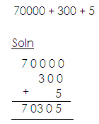3. Find the expanded number below.

4. Which number has been expanded to give (9x102) + (1x101) + (3x100)?

**Soln.**

(9x102) + (1x100) + (3 x100)

(9x10x10) + (1x10) + (3x1)

900 + 10 + 3

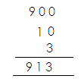

**Activity:**

Write the following as single numerals.

a. 90000 + 3000 + 40 + 50 + 8

b. (7x1000) + (4x100) + (3x10) + (2x1)

c. 4 hundreds + 7 tens

d. (2x100) + (3x10) + (5 x1)

e. (7x103) + (8x102) + (3x101) + (6x100)

f. 40000 + 8000 + 700 + 90 + 3

g. (4x102) + (5x101) + (4x100)

h. 70000 + 700 + 4

**WRITING FIGURES IN WORDS**

Examples:

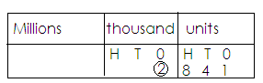1. Write 2841 in words.

Two thousand eight hundred forty – one.

2. Write 45617 in words.

|  |  |
| --- | --- |
| thousand | Units |
| H T 0  4 5 | H T 0  6 1 7 |

Forty-five thousand, six hundred seventeen.

**Activity:**

Write the following numbers in words.

a. 12,214 b. 98172

c. 99466 d. 812

e. 96 f. 98544

g. 20,086 h. 49,019

**WRITING NUMBERS IN FIGURES**

**Examples**:

1. Write: Twelve thousand eight hundred thirty-two in figures.

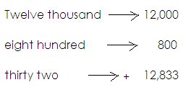 **Solution**:

2. Write: “Thirty-seven thousand, four hundred eighteen” in figures.

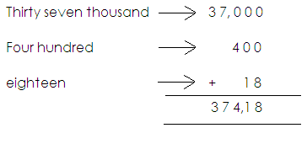 **Soln:**

**Activity:**

**Write the following in figures.**

1. Fourteen thousand, five hundred sixty-two.

2. Twenty thousand, eight hundred forty-nine.

3. Sixty-one thousand, three hundred eighty.

4. Seventy-seven thousand, eight

5. Ninety-seven thousand, one hundred ninety – nine

6. Eighty – four thousand, two hundred fifteen.

7. Seventy – two thousand five.

**ROUNDING OFF WHOLE NUMBERS**

Rounding off is the way of approximating numbers according to the nearest place value.

**NOTE**:

* When rounding off whole numbers, digits after the required place value will turn to 0.
* Base on the digit which is on the right of the figure in the mentioned place value to either round down or round up.
* If the digit on the right is 0,1, 2, 3, or 4, round down by adding 0 to the digit in the mentioned place value.
* 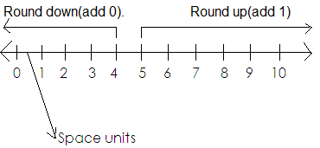If the digit on the right is 5,6,7,8 or 9, round up by adding one to the digit in the mentioned place value.

**Examples**:

1. Round off 94 to the nearest tens.

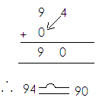 **Soln.**

2. Round off 56 to the nearest tens.

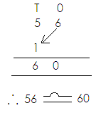 Soln

3. Round off 437 to the nearest hundreds.

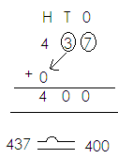 **Soln.**

4. Round off 5753 to the nearest hundreds.

**Soln.**

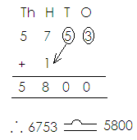

**Activity:**

1. Round off to the nearest tens.

a. 8 b. 15 c. 901

d. 97 e. 736

2. Round off the following numbers to the nearest hundreds.

a. 567 b. 937 c. 82

d. 8993 e. 8158 f. 849

**FORMATION OF NUMERALS FROM DIGITS**

**NOTE:**

* There is no number that starts with digit zero (0).
* No commas should be indicated in the numbers formed.
* When forming the smallest, arrange the given digits in ascending order without commas.
* When forming the biggest numeral, arrange the given digits in descending order without.

**Examples**:

1. Given the digit 7, 2 and 5.

a. Form the smallest digit numeral using the above digits.

**Soln.**

Smallest 257

b. Form the biggest 3-digit numeral using the above digits.

**Soln.**

Biggest 752

c. What is the sum of the smallest and the biggest numerals formed?

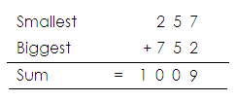  **Soln.**

d. Find the difference of the biggest and the smallest numerals formed above.

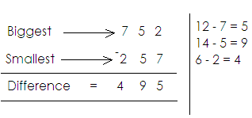 **Soln.**

2. Given the digits 8, 2,4 and 3;

a. Form the smallest digit numeral using the above digits.

**Soln.**

Smallest 2348

b. Form the biggest 4-digit numeral using the above digits.

**Soln.**

Biggest 8432

c. Find the sum of the smallest and the biggest numerals formed.

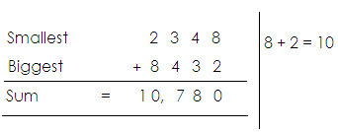 **Soln.**

d. What is the difference between the biggest and the smallest numerals formed?

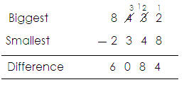 **Soln.**

3. Given the digits 6, 0 and 9. Form all the three-digit numerals using the given digits.

**Soln.**

|  |  |
| --- | --- |
| 6 | 609,690 |
| 0 |  |
| 9 | 906,960 |

The digits are: 609, 690, 906, 960

**Activity:**

1. Using digits 4, 8 and 1;

a. Form the smallest 3-digit numeral using the above digits.

b. Form the biggest 3-digit numeral using the digits above.

c. Find the sum of the smallest and the biggest numerals formed.

2. Given the digits 5, 6 and 0.

a. Form the digits 5, 6 and 0.

b. Form the biggest 3-digit numeral.

c. Find the sum of the smallest and biggest.

d. What is the difference between the biggest and the smallest?

3. Using digits 2, 7, 5 and 3;

a. Form the smallest 4-digit numeral.

b. Form the biggest 4-digit numeral.

c. Find the difference of the biggest and the smallest numerals formed.

4. Given the digits 3, 7 and 4. Form all the 3-digit numerals.

**NUMBERS AND NUMERALS**

**Number**

Number is the quantity of something.

**Numeral**

Numeral is a symbol that represents a number.

**TYPES OF NUMERALS**

There are two types of numerals.

These are:

1. Hindu Arabic numerals

2. Roman numerals

**HINDU ARABIC NUMERALS**

These are numerals that are used in most parts of the world.

**Major Hindu Arabic Numerals**

0, 1, 2, 3, 4, 5, 6, 7, 8, 9

**ROMAN NUMERALS**

**Basic Roman numeral table.**

|  |  |  |  |  |  |  |  |
| --- | --- | --- | --- | --- | --- | --- | --- |
| Hindu Arabic | 1 | 5 | 10 | 50 | 100 | 500 | 1000 |
| Roman numerals | 1 | V | X | L | C | D | M |

**NOTE:**

All roman numerals should be written in capital letters.

**Roman numerals got by repeating I**

2 = 1 + 1

= II

3 = 1 + 1 + 1

= III

**Roman numerals got by repeating X**

20 = X+X

= XX

30 = X + X + X

= XXX

**Roman numerals got by adding to 5.**

6 = 5 + 1

= VI

7 = 5 + 2

= VII

8 = 5 + 3

= VIII

**Roman numerals got by adding to 50.**

60 = 50 + 10

= LX

70 = 50 + 20

= LXX

80 = 50 + 30

= LXXX

**Roman numerals got by adding to ten**

11 = 10 + 1

= XI

12 = 10 + 2

= XII

13 = 10 + 3

= XIII

**Roman numerals got by subtracting from 5.**

4 = 5 – 1

= IV

**Roman numerals got by subtracting from 50.**

40 = 50 – 10

= XL

**Roman numerals got by subtracting from 100**

90 = 100 – 10

= XC

**Hindu Arabic and Roman numerals**

|  |  |
| --- | --- |
| **Hindu Arabic** | **Roman numerals** |
| 1  2  3  4  5  6  7  8  8  10  20  30  40  50  60  70  80  90  100 | I  II  III  IV  V  VI  VII  VIII  IX  X  XX  XXX  XL  L  LX  LXX  LXXX  XC  C |

**CHANGING HINDU ARABIC NUMERALS TO ROMAN**

**Examples:**

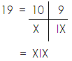1. Write 19 in Roman numerals.

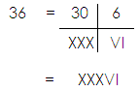2. Change 36 to Roman numerals.

**Activity:**

Write the following in Roman numerals.

1. 11 2. 13 3. 18 4. 24

5. 35 6. 38 7. 22 8. 31

9. 17 10. 40 11. 69 12. 47

**CHANGING ROMAN NUMERALS INTO HINDU ARABIC NUMERALS**

**Examples:**

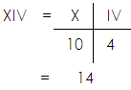1. Write XIV in Hindu Arabic numerals.

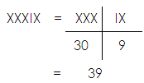3. Write XXXIX in Hindu Arabic numerals.

**Activity:**

Change these Roman numerals to Hindu Arabic numerals

1. XXII 2. XLII 3. IV 4. L

5. XXIV 6. XIX 7. XXXVII 8. VII

**WORD PROBLEMS INVOLVING ROMAN AND HINDU ARABIC NUMERALS.**

**Examples**:

1. Henry’s age is 8. Write his age in Roman numerals.

8 = VIII

2. Mukiibi’s vehicle has been driven for 24 months. Write the months in Roman numerals.

**Soln.**

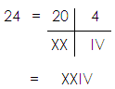

**Activity:**

1. Waiswa picked 14 mangoes. Write the number of mangoes he picked in Roman numerals.

2. Ninsima bought 30 eggs. Express the number of eggs she bought as Roman numerals.

3. These are 43 girls and 42 boys in a primary five class. Express the number of boys and that of girls as Roman numerals.

4. The numeral XXV is written on the door of my father’s office. Write that numerals in Hindu Arabic.

**ADDITION AND SUBTRACTING OF ROMAN NUMERALS**

**Addition**

**Examples**:

1. Workout: XX + VII

= 20 + 7

= 27

= XXVII

2. Workout: XX + IX

= 20 + 9

= XX + IX

= XXI

**Subtraction**

a. Workout: XXVI – XXII b. Workout: IX - V

(30+6) – (20 – 2) = 9 - 5

= 36 – 22 = 4

= 14 = IV

= XIV

**TOPIC 3:**

**OPERATION ON NUMBERS**

**ADDITION OF WHOLE NUMBERS.**

**A. Without regrouping**

**Examples:**

1. Add 138736 + 421022

**Soln.**

Hth Tth Th H T O

1 3 8 7 3 6

+ 4 2 1 0 2 2

5 5 9 7 5 8

2. Work out

Th H T O

7 4 6 4

+ 2 4 2 5

9 8 8 9

**Activity:**

Add the following

1. 426 + 353 2. 1114 + 7331 3. 11210 + 2314 4.207 + 320 + 321

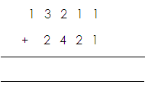

5. 3 6 4 2 5 6. 3 4 9 7 3 7.

+ 2 0 1 1 3 + 1 4 0 1 5

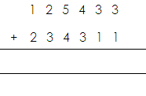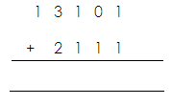8. 9.

**B. With regrouping**

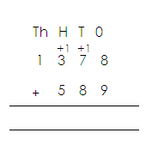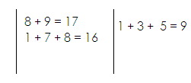 **Examples:**

1. Add:

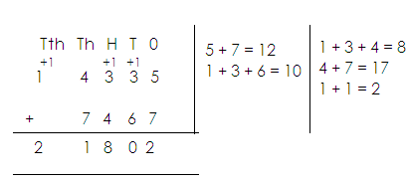2. Add:

**Activity:**

Workout the following.

1. 4 2 0 7 5 3 + 1 3 6 4 8 1 2. 2 4 5 6 + 5 3 2 + 4 0 4

3. 1 3 7 8 + 5 3 2 + 4 0 4 4. 1 4 8 3 2 + 4 2 3 8

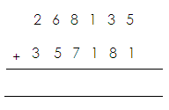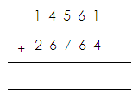5. 6.

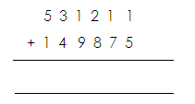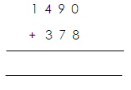

7. 8.

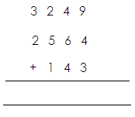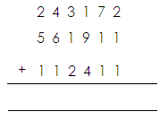

9. 10.

**WORD PROBLEMS INVOLVING ADDITION OF NUMBERS**

**NOTE:**

Sum is the answer got after addition.

**Examples**

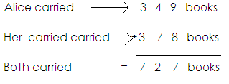1. Alice carried 349books, her brother carried 378books. How many books were carried altogether?

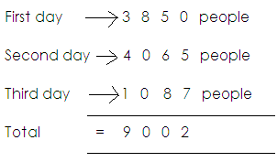2. There were 3850 people at an agriculture show on the first day. On the second day there were 4065. On the third day there were 1087 people. How many people attended the show during the three days?

**Activity:**

1. A school has 440 boys and 839 girls. How many girls are there altogether?

2. In a village, there are 804 men and 1011 women. What is the total number of adults in the village?

3. A book has 329 pages. Another book has 645 pages. How many pages do the two books have?

4. Matovu had 875 ewes, 400 rams and 175 lambs. How many sheep does he have altogether?

5. What is the sum of 3020 and 404?

6. What is 6125 plus 605?

7. Kapasi borrowed sh. 18000 from a friend, sh. 6000 from his uncle and sh. 25000 from a bank. How much money did he borrow altogether?

8. Alex is 9 years old. His brother is 15 years old. Find their total age.

**SUBTRACTION OF WHOLE NUMBERS**

**A. WITHOUT REGROUPING**

**Examples.**

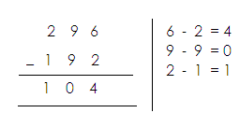1. Subtract:

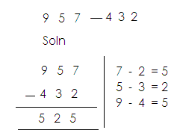2. Work out:

**Activity:**

**Subtract the following**

1. 36 – 24

2. 946 - 414

3. 4789 - 1434

4. 924735 - 30024

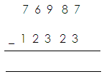5. Subtract:

**B. WITH REGROUPING**

**Examples**

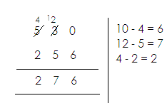1. Subtract: 6 4 6 - 5 9 2 2. Subtract: 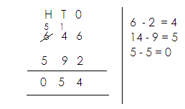

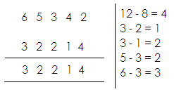

3.

**Activity:**

Subtract the following.

1. 7395 - 3826 2. 96830 - 41615 3. 28059 - 13644

4. 120 – 23 5. 7265 – 2436

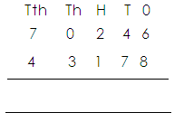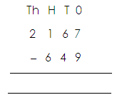6. 7.

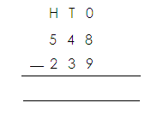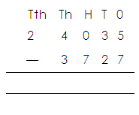8. 9.

**WORD PROBLEMS INVOLVING SUBTRACTION OF WHOLE NUMBERS**

**NOTE**:

**Difference**

Difference is the answer got after subtraction.

**Range.**

Rangeis the answer got after subtracting the lowest from the biggest.

Other key words include;

* Take away
* Subtract
* Minus
* Reduce
* Deduct
* Decrease
* Remain

**Examples**

1. What is the difference between 243 and 37?

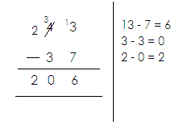 **Solution**

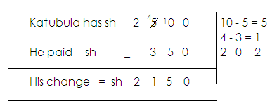2. Katabula has sh. 2500. He bought a book for sh. 350. What was his change?

3. In a school there are 1256 pupils, 578 are boys. How many are girls?

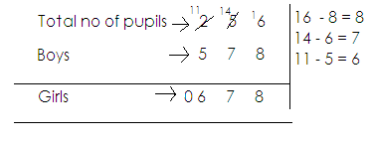 Soln.

**Activity**

1. Kibuli Demonstration School has 1000 pupils. There are 519 boys. How many girls are there?

2. Subtract 5307 from 8450.

3. Last month Onek sold 1200 of his 2350 chicken. What was he left with?

4. What is 376850 less than 140585.

5. Galiwango has sh. 24309 and Nkema has sh. 56257.

6. Take a way 53 from 111

7. What number must you add to 36 to get 176?

8. By how much is sh. 4824 greater than sh. 2248?

9. Aman had 8790 heads of cattle, 3021 were sold. How many remained?

**MAGIC SQUARE**

**NOTE:**

1. First get the magic sum.

2. The sum if all the numbers arranged in columns or rows or diagonals must be the same.

**Examples:**

1. Complete the magic square below.

|  |  |  |
| --- | --- | --- |
| 7 | a | 5 |
| b | 4 | 6 |
| 3 | c | 1 |

(a) Find the magic sum.

Magic sum = 3 + 4 + 5 or 7 + 4 + 1 or 5 + 6 + 1

= 12 = 12 = 12

(b) Find the value of a, b, and c.

|  |  |  |
| --- | --- | --- |
| 7 | a | 5 |

a = 12 – (7 + 5)

a = 12 – 12

a = 0

|  |  |  |
| --- | --- | --- |
| B | 4 | 6 |

b = 12 - (4+6)

b = 12 – 10

b = 2

|  |  |  |
| --- | --- | --- |
| 3 | c | 1 |

c = 12 – (3 + 1)

c = 12 – 4

c = 8

**Activity:**

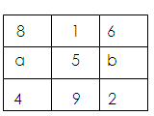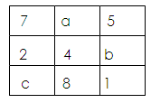Find the missing number in the magic square below.

1. 2.

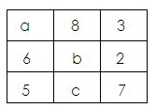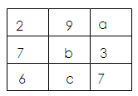

1. 4.

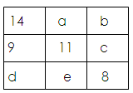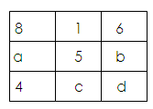5. 6.

**MULTIPLICATION (x)**

**Multiplication using repeated addition.**

**Examples:**

1. Work out 2 x4 using repeated addition.

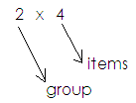 **Soln.** Therefore 2 x 4 = 4 + 4

= 8

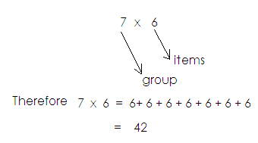2. Work out 7 x 6 using repeated addition.

3. Work out 5 + 5 + 5 + 5 using multiplication.

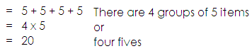 **Soln.**

**Activity**

1. Simplify the following multiplication statements using repeated addition.
2. 3 x 4 b. 2 x 7 c. 6 x 9 d. 4 x 8 c. 9 x 5
3. Work out the following addition statement using multiplication.
4. 4 + 4 + 4 + 4 + 4 + 4 b. 3 + 3 + 3 + 3 + 3 c. 7 + 7 + 7 + 7 + 7

d. 9 + 9 + 9 e. 10 + 10

**Multiplication numbers**

Two by one-digit numbers or Three by one-digit numbers.

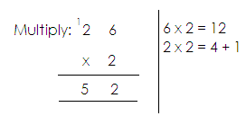**Examples:**

1.

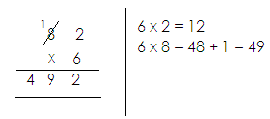2. Work out:

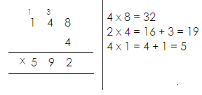3. Simplify:

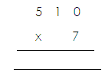**Activity:**

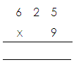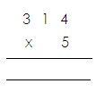Multiply the following

1. 2. 3

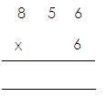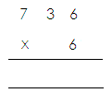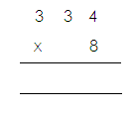4. 5 6.

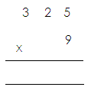

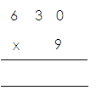 8. 9.

7.

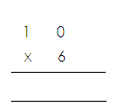

10.

**WORD PROBLEMS INVOLVING MULTIPLICATION**

Examples:

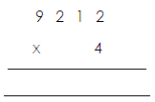1. Multiply: 9212 by 4

2. A bunch of matooke costs sh. 3900. What is the cost of 8 bunches?

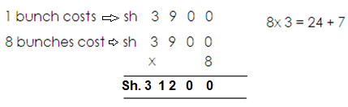

**Activity:**

1. Multiply 9314 by 3

2. What is the product of 2416 and 5?

3. What is the product of 2920 and 8?

4. I bought 4 text books at sh. 2782 each. How much did I pay?

5. A train carries 827 people. If it makes 3 trips, how many people did it carry?

6. A worker is paid sh. 6960 a day. How much will the worker get if he works for 7 days?

7. Each night the Elves made 24 pairs of shoes for the shoe maker. How many pairs of shoes did the Elves make in 128 days?

**MULTIPLICATION OF TWO DIGIT NUMBERS**

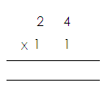 **Examples**:

1. Multiply:

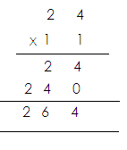

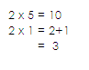 Soln

1. 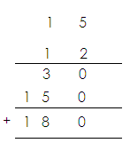Work out:

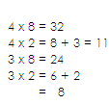

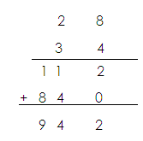 3. Multiply:

**Activity:**

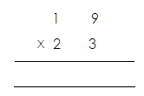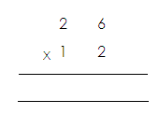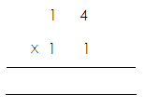Multiply the following

1. 2. 3.

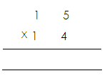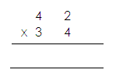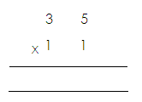4. 5. 6.

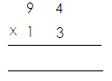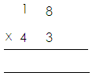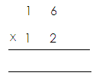7. 8. 9.

**DIVISION OF WHOLE NUMBERS**

**Division of numbers using repeated subtraction**

**Examples:**

Work out: 12 ÷ 3 using repeated subtraction

12 ÷ 3

12 – 3 = 9

9 – 3 = 6

6 – 3 = 3

3 ÷ 3 = 0

4 times

Therefore 12 ÷ 3 = 4

Workout: 15 ÷ 5 using repeated subtraction

15 – 5 = 10

10 – 5 = 5

5 - 5 = 0

3 times

Therefore: 15 ÷ 5 = 3

**Activity:**

a. 12 ÷ 2 = b. 18 ÷ 2 = c. 10 ÷ 2 = d. 20 ÷ 2 = e. 18 ÷ 2 =

f. 25 ÷ 5 = g. 36 ÷ 9 = h. 45 ÷ 9 =

**DIVISION USING LONG DIVISION**

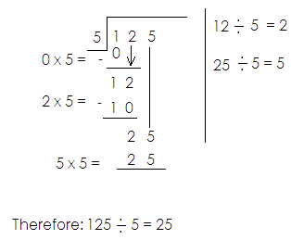1. Divide: 125 ÷ 5

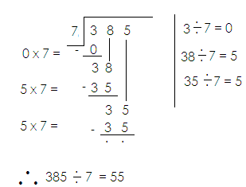2. Divide: 385 ÷ 7

**Activity:**

Divide:

1. 2. 3. 4.



5. 6.

**MORE ABOUT DIVISION OF NUMBERS USING LONG DIVISION**

Examples:

1. Divide Soln.

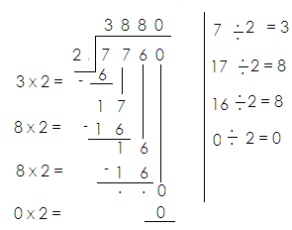

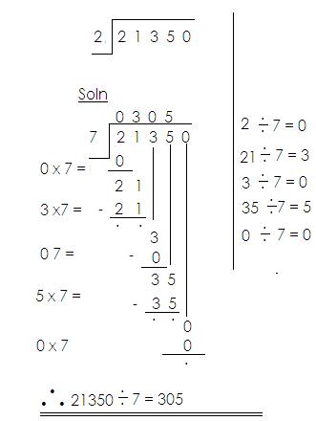2. Divide: 21350 ÷ 2

**Activity:**

Divide the following

1. 2. 3.



4. 5. 6.

**WORD PROBLEMS INVOLVING DIVISION OF NUMBERS.**

**Examples:**

1. There are 120 oranges in 2 bags. How many oranges are in each bag?

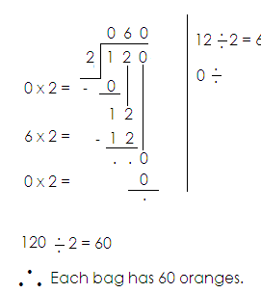 Soln.

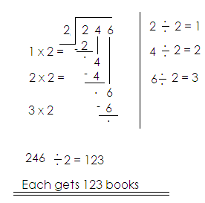2. Divide 246 text books among 2 classes.

**Activity:**

1. Divide 246 pens among 3 schools.

2. Share 246 books among 6 pupils.

3. 8 cars used 72632 litres of petrol equally. How many litres did each car use?

4. A district officer paid sh. 72000 to 10 workers. How much did each get?

5. A school bursar collected a total of sh. 46249 from 7 pupils. How much did each pay?

6. A team of 7 players was given sh. 40,047 for winning the trophy. How much was given to each player?

7. An employee received sh. 9500 after working for 5 days. How much was he paid for each day?

TOPIC 4:

**PATTERNS AND SEQUENCES**

**Sequence.**

Is a list of numbers that are in order.

**For example.**

1, 2, 3, 4, 5, …

2, 4, 8, 16, 32, …

**Series.**

Is the sum of numbers in the given sequence.

1 + 2 + 3 + 4 + 5 + …

2 + 4 + 8 + 16 + 32 + …

**Pattern:**

This is a repetition of events in a particular order.

**Note:**

Patterns form a sequence.

**Types of numbers**

**Whole numbers:**

These are positive integers including zero (o)

These are numbers that are not fractions

**Note**:

The first whole number is zero (0)

**Examples**:

0, 1, 2, 3, 4, 5, 6, 7, 8, 9, …

**Note**:

Whole numbers have a pattern of +1 and -1 in ascending and descending orders respectively.

**Counting numbers / Natural numbers:**

These are numbers that show concrete quantity of things.

**Note**:

The first counting number is one (1)

**Example**.

1, 2, 3, 4, 5, 5, 6, 7, 8, …

**Note:**

Counting numbers have a pattern of +1 in ascending order and -1 in descending order.

**Examples**

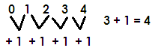Find the next number in the sequence

Or

0, 1, 2, 3, 4 (whole numbers)

Find the next numbers in the sequence.

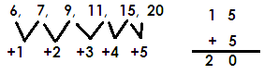

Complete the sequence below.



Find the next number in the series of;

5 + 6 + 8 + 11 + 15 + …

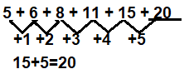

**Activity**:

1. Find the next number in the following numbers.

1. 4, 4, 5, 7, 10, _______
2. 3, 10, 7, 4, _______
3. 16, 11, 7, 4, __________
4. 3, 5, 4, 6, 5. ______

2. Find the sum of the next two numbers in the sequences below.

5, 6, 8, 11, 15, _____, _____

3. Find the next number in the following series;

a) 4 + 5 + 6 + 7 + 8 + _____

b) 31 + 30 + 28 + 25 + 21 + _____

c) 11 + 12 + 14 + 17 + 21 + 26 + _____

**Even numbers**

These are numbers that are exactly divisible by two e.g., 0, 2, 4, 6, 8, …

**Note**:

* The first even number is zero (0).
* Even numbers have a pattern of +2 in ascending and -2 in descending order.
* Any number that ends with 0, 2, 4, 6, or 8 is on even numbers.

**Odd numbers**

These are numbers that are not exactly divisible by two (2)

**Examples**:

1, 3, 5, 7, 9, …

**Note:**

Odd numbers have a pattern of plus two (+2) in ascending and minus two (-2) in descending order.

-Any number that ends with

1, 3, 5, 7, or 9 is an odd number.

**Sequence of Even and odd numbers**

**Examples:**

1. Complete the sequence below.

**Or**

0, 2, 4, 6, 8, 10 (Even numbers)

2. Find the next number in the sequence.

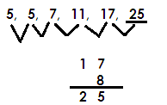3. Complete the sequence below.

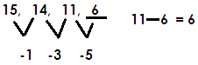4. Find the missing numbers in the sequence below.

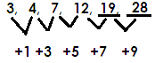5. Find the sum of the next two numbers in the sequence below.

12 +7 = 19 19 + 9 = 28

Sum = 19 + 28

= 47

6. Find the next number in the series of;

 21 + 19 + 17 + 15 + ____

**Activity:**

1. Find the next numbers in the following sequences.

1. 2, 4, 8, 14, _________
2. 6, 7, 10, 15, ___________
3. 14, 12, 8 _________

2. Find the product of the next two numbers in the sequence below.

5, 7, 9, 11, ______, __________

3. Find the product of the next two numbers in the sequence below.

20, 18, 14, ______, _______

4. Find the next numbers in the following series;

a) 11 + 13 + 15 + 17 + 19 + _____ + ______

b) 36 + 34 + 32 + 30 + 28 + _____ + ______

c) 8 + 6 + 4 + 2 + ______

**MULTIPLES**

**What are multiples?**

These are numbers got by multiplying a given number by counting numbers.

**Finding multiples of numbers**

**Examples**

1. Find the multiples of 2 less than 15.

**Solution**

2 x 1 = 2 M 2 = (2, 4, 6, 8, 10, 12, 14)

2 x 2 = 4

2 x 3 = 6

2 x 4 = 8

2 x 5 = 10

2 x 6 = 12

2 x 7 = 14

2. Find multiples of 8 between 7 and 42.

**Soln.**

8 x 1 = 8

8 x 2 = 16 M 8 = (8, 16, 24, 32, 40)

8 x 3 = 24

8 x 4 = 32

8 x 5 = 40

8 x 6 = 48

3. Find the sum of the 4th and 6th multiples of 4.

**Soln.**

4 x 1 = 4

4 x 2 = 8

4 x 3 = 12

4 x 4 = 16 4th

4 x 5 = 20

4 x 6 = 24 6th

4 x 7 = 28

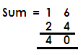

**Activity**:

1. Find multiples of 6 less than 20.

2. List the first 6 multiples of 4.

3. Find the multiples of 5 between 12 and 36.

4. List the first 4 multiples of 9.

5. Find the sum of the 3rd and the 5th multiples of 3.

6. What is the difference between the 6th and the 3rd multiples of 7?

7. Find the sum of the second (2nd) and the 4th multiples of 12.

8. Find the multiples of 2 greater than 7 and less than 19.

**FINDING COMMON MULTIPLES OF NUMBERS**

Example 1

List the first 3 common multiples of 2 and 3.

**Soln.**

M2 = (2, 4, 6, 8, 10, 12, 14, 16, 18, 20 )

M3 = (3, 6, 9, 12, 15, 18, 21, 24, 27, 30 )



Common Multiples = (6, 12, 18)

**Activity:**

1. List the first 3 common multiples of;

(a) 2 and 4 (b) 2, 3 and 4 (c) 4 and 6 (e) 4 and 8

**LOWEST COMMON MULTIPLES**

(LCM /LCD)

**Examples 1**

Find the LCM of 5 and 6.

M5 = (5, 10, 15, 20, 25, 30, 35, 40, 45, 50, …)

M6 = (6, 12, 18, 24, 30, 36, 42, 48, 54, 60, …)

Common multiples = 30 …

LCM of 5 and 6 = 30

**Activity**:

Find the LCM of the following

a. 8 and 6

b. 4 and 6

c. 12 and 8

d. 4 and 9

e. 12 and 5

f. 7 and 8

g. 12 and 20

**FACTORS**

These are numbers that can divide a given number exactly.

**FINDING FACTORS OF NUMBERS**

**NOTE**:

* One is a factor of every number.
* A number is a factor of itself.
* Factor x factor = Product

**Examples:**

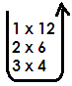1. List all the factor of 12.

F12 =



F12 = 1, 2, 3, 4, 6, 12

1. 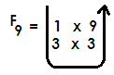Write all factors of 9

F9  = 1, 3, 9



**Activity:**

Write all factors of the numbers below.

1. 15 2. 25 3. 18 4. 24

5. 36 6. 48 7. 21

**FINDING COMMON FACTORS OF NUMBERS**

**Examples:**

1. Find the common factors of 12 and 20

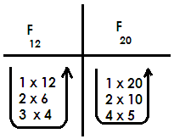**Soln.**





Common factors = (1, 2, 4)

**Activity:**

1. 6 and 8 2. 8 and 12

3. 12 and18 4. 12 and 15

5. 18 and 24 6. 20 and 30

7. 14 and 21 8. 4 and 6

9. 3 and 5 10. 10 and 20

**FINDING HIGHEST / GREATEST COMMON FACTOR**

**Examples**

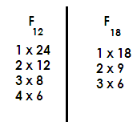Find the Greatest common factor of 18 and 24.

Common factors = 1, 2, 3, 6

= 1, 2, 3, 4, 6, 8, 12, 24

= 1, 2, 3, 6, 9, 18

GCF = 6 or HCF = 6

Find the Highest common factor of the following

1. 9 and 12

2. 8 and 12

3. 20 and 36

4. 30 and 40

5. 15 and 18

6. 9 and 21

7. 12 and 18

8. 24 and 36

9. 3 and 5

10. 5 and 7

**LOWEST COMMON FACTOR L.C.F**

**Note**:

The lowest common factor of numbers is 1

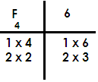Find the lowest common factor of 4 and 6.





Common factors = (1, 2)

L.C.F = 1

**PRIME NUMBERS**

Prime numbers

A prime number is a number with only two factors i.e., one and itself.

The first Prime number is two (2).

**Examples:**

(2, 3, 5, 7, 11, 13, 17, …)

**Sequence of Prime numbers.**

**Examples**

Find the next number in the sequence

2, 3, 5, 7, …

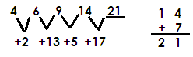Complete the sequence

**Activity:**

1. List the first six prime numbers

2. Find the sum of the 4th and 2nd prime numbers.

3. List prime numbers between 0 and 10.

4. Find the next number in the sequence below.

(a) 11, 7, 5, 3, ___________

(b) 8, 10, 13, ____________

5. Find the next number in number in the series below;

a) 2 + 3 + 5 + 7 + _____ + ______

b) 19 + 17 + 13 + 11 + ______ + _____

**COMPOSITE NUMBERS**

These are numbers with more than two factors.

The first composite number is 4.

**Example**

4, 6, 8, 9 10, 12, …

**Note:**

Composite numbers don’t have a clear pattern.